 **Postgraduate Study and Summer Jobs Fair**

***Main Concourse – 28th February – 12pm-3pm***

**Exhibitors and Opportunities**

cid:image002.png@01CE24B0.9DD8ACB0Summer jobs – tbc.

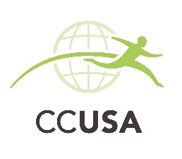

CCUSA is Ireland's top summer camp and international work adventure specialist. This means you will be in the BEST hands when working and traveling abroad!

We offer something for everyone, including working at a summer camp in America, Canada, Croatia or Russia where you will lead children in various activities including sports, arts and outdoor adventures.  Or maybe spend a summer or winter season working and playing at one of the premier resorts in the Canada. These are just a few of the great opportunities that CCUSA has to offer you!

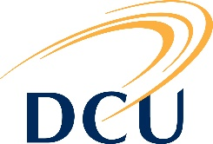

Here is a link to our online PG prospectus: <http://www4.dcu.ie/courses/index.shtml?del=postgraduate>

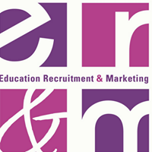**Train to Teach in England and Scotland:** We will be offering information and advice to your students about Teacher Training options available in England and Scotland.

We work with a number of Universities in England and Scotland who offer the one year Teacher Training Education (PGCE/PGDE) so will be representing these universities on this day.

Loans are available to cover the cost of tuition fees and generous tax free bursaries of up to £26,000 are available in England in certain subjects, so we will give advice on this also.

Students will learn more about, entry requirements; application process; personal statements; interviews and financing.



Information about the various EU institutions and agencies.

The latest news about EU affairs and events.

Information about citizen rights in the EU.

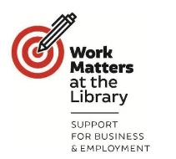Promoting the key role of libraries in supporting users in the transition into jobs and careers, in seeking work, undertaking their own endeavours and/or becoming entrepreneurs.

Services including business information, research resources, working and meeting space, IT facilities, events, and job skills support that are already widely provided in public library services.

Are you interested in study or research in the USA? Presentation – A0004 at 1pm.

 Here are the links to our courses: <https://www.itsligo.ie/courses/> & <https://www.itsligo.ie/research/> & <https://www.itsligo.ie/onlinelearning/>



We are a precision engineering company and are in business over 35 years. We have the latest CNC technology and further details on our company can be found on [www.killalaprecision.com](http://www.killalaprecision.com).

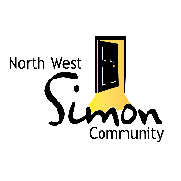

Volunteering opportunities with North West Simon Community: <http://www.northwestsimon.ie/?pagid=volunteer>

Here is a link to our courses pages: [www.nuigalway.ie/courses](http://www.nuigalway.ie/courses) Also our prospectus is available here: [www.nuigalway.ie/pgp](http://www.nuigalway.ie/pgp)

Particular focus on: **MSc Exercise Physiology and its Application in Therapy**:

<https://www.nuigalway.ie/courses/taught-postgraduate-courses/exercise-physiology.html>

Link to Course Video: <https://youtu.be/175nnGKPMD4>

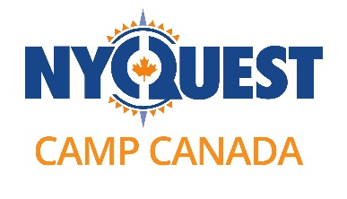 Here is a list of roles available at the camps we work with:

**Camp Counsellor / Activity Specialist / Early Years Counsellor / Camp Coordinator**

Camp Counsellors and Activity Specialists work and usually live directly with children between the ages of six and sixteen. Counsellors and campers experience a full schedule of activities during the day and typically sleep in cabins or tents.

**Support Staff (Kitchen/Maintenance)**

Support Staff are essential to the smooth running of a camp. They work behind the scenes to ensure that camp is a well-maintained, well-fed operation! Support staff usually stay in cabins with other support staff, not with campers.

Here’s a url to the different roles applicants can look at <https://www.go-nyquest.com/your-role-at-camp/>

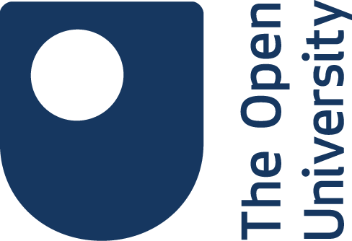

Gain a highly respected postgraduate qualification with the Open University without putting everything else on hold to achieve it. We are experts at combining flexibility with quality, so everything about learning with us is designed with convenience in mind.

 **Department of Nursing, Health Sciences and Disability Studies**

MA /PG Dip of Health Sciences (Nursing/Professional Studies) - PG Dip in Nursing (Community Mental Health) - PG Dip in Health Sciences (Healthcare Quality Studies) - PG Cert / Dip in Applied Health and Wellness Coaching - Stand Alone Professional Development Modules - Disability Equality Studies / Disability Studies

**Centre for Lifelong Learning (CLL)**

MA in Leadership and Management for the Community and Public Sector - MA in Historical and Heritage Studies of the North West - PG Cert in Teaching English as a Foreign Language (TEFL) - Bachelor of Nursing (International) - Diploma of Arts in Folklore and Heritage of the North West - Diploma in Foundation Studies (Pre-third Level) - Stand Alone Modules - Continuing Professional Development Courses for Nursing, Carers, Healthcare Personnel and Organisations

**Home Economics Department**

MA in Education (Home Economics) - MA in Science in Food Innovation - MA in Conflict Management - PG Dip in Science for Primary School Educators - PG Cert in Mediation and Conflict Resolution

**Education Department**

MA / PG Dip / PG Certificate in Education and the Law - MA / PG Dip / PG Cert in Pastoral Care /Chaplaincy Studies - Stand Alone Modules - BA / Dip / Cert in Theology and Community Involvement - Cert in Religious Education for Primary Schools - Dip in Foundation Studies: Access Course for Higher Education (School Leavers and Mature Students)

**Centre for Special Educational Needs, Inclusion and Diversity**

MA / PG Dip in Special Education - MA / PG Dip / PG Cert in Special Educational Needs (Autism Spectrum Disorder) - MA / PG Dip / PG Cert in Professional Studies in Special Educational Needs - MA / PG Dip / PG Cert in Specific Learning Difficulties - Stand Alone Modules - Certificate in Special Educational Needs for Special Needs Assistants

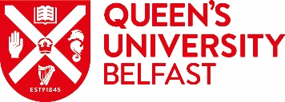Queens University Belfast is a world-leading university with international recognition and part of the Russell Group 24 of international research-intensive universities. Queen’s University support outstanding students and staff, provides world-class facilites for work and learning and is forefront at conducting leading-edge education and research that focuses on the needs of society. At the heart of our Visoin for Queen’s is our dedication to creating a vibrant and ambitious postgraduate and postdoctoral culture across the University. To find out more about Postgraduate study at Queen’s University Belfast, please visit [www.qub.ac.uk/pg-study](http://www.qub.ac.uk/pg-study)

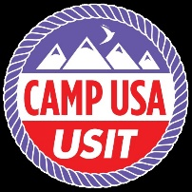

J1 Options – J1 Classic – Camp USA – Soccer Coaching USA – Camp Canada.

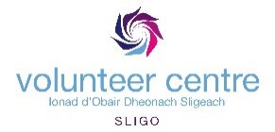

Volunteer Centre, Sligo are primarily advertising Volunteering Opportunities with Not For Profit groups in the Sligo area: [www.volunteersligo.ie](http://www.volunteersligo.ie)