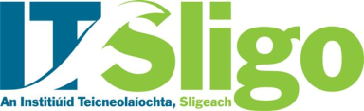 SUBJECT ACCESS REQUEST FORM
Under the General Data Protection Regulation (GDPR) it is your right to request a copy of any personal data that we hold on you. Please note that this form is to aid the Subject Access Request process. Further information can be found at https://www.itsligo.ie/dataprotection/

- DETAILS OF REQUESTOR
Name:
Address:
E-mail Address:
Telephone Number:
Student ID Number (if applicable)
If you are a current or former staff member, please provide details of the Departments worked in within the Institute:
If neither a current or former student nor staff member, please provide details of your relationship with the Institute:

- FORM OF ACCESS
My preferred form of access to the data is:

- DETAILS OF REQUEST
In accordance with the data protection legislation, I request access to the following personal data that I believe IT Sligo holds about me:

Please provide as much information as possible to help the Institute locate the information such as the time periods concerned, names of members of staff who you may have dealt with or who may be able to locate the information, the Department or areas of the Institute that are most likely to hold the relevant information.
I acknowledge that, before I am given access to personal information about myself, I may be asked for identification.

Signed: Date:
Completed forms to be sent to: dataprotection@itsligo.ie or by post to Data Protection Officer, Institute of Technology Sligo, Ash Lane, Sligo F91 YW50

