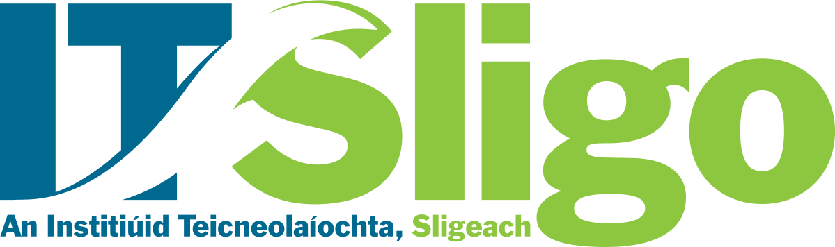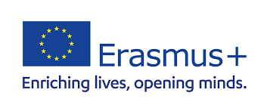

Erasmus+ Policy Statement
Current Irish Government policy for higher education places considerable emphasis on international activities as a key determinant of future growth and development. IT Sligo recognises its responsibility for the continuing economic development of its region and beyond and therefore aligns its international strategy with national policy in this regard. Our Erasmus+ Policy is a vital component of our international strategy which is also includes the pillars of internationalisation at home and internationalisation of research.

Recognising EU commitment in the 2021-2027 Erasmus+ programme to offering opportunities to more participants and a wider range of organisations, IT Sligo will diversify the range of Erasmus+ programmes in which it participates. International Inter-Institutional Agreements will continue to be the primary medium through which IT Sligo participates in Erasmus+. IT Sligo’s international inter-institutional linkages aim to reach beyond traditional forms of staff and student mobility and will broaden to include Blended Intensive Programmes, virtual, doctoral and student alumni placement mobilities. IT Sligo will engage with the European Universities Initiative with our RISEN network partners.

IT Sligo aims to deliver a high-quality educational experience, enhanced by strong integration of international and domestic students- recognising that an international dimension and experience adds significant value to career outcomes along with personal and social growth. IT Sligo has a long and proud history of participation in the Erasmus+ and its predecessor programmes and wishes to place greater strategic importance on Erasmus + participation as a core component of its internationalisation strategy.

IT Sligo will seek to continually improve and innovate across a range of internationalisation activities. The Erasmus+ programme affords IT Sligo a unique opportunity to learn from our respected institutional partners and develop internationalisation models of best practice in priority areas of access, diversity and inclusion and the development of greener and digitally fit societies. Strategically IT Sligo will seek to maintain its Erasmus+ incoming student numbers into the future while seeking institutional partnerships which will assist us in growing our outbound student mobility numbers and addressing the historical problem of imbalance in inbound and outbound student mobility flows. Erasmus+ students provide welcome diversity on our campus and contribute greatly to our ‘Internationalisation at Home’ agenda. Domestic students will continue to benefit from intercultural learning experiences through on and off-campus encounters with our international students. Staff teaching and training mobilities will heighten the intercultural competencies of our teaching and professional support services staff.

IT Sligo will aim to facilitate greater outward mobility for staff and students. The significant growth in demand for study abroad and work-based learning opportunities among the domestic student population in recent years alone warrants the inclusion of study abroad opportunities for all categories while attention to less represented groups will be a particular focus. IT Sligo strives to increase outward placement mobilities amongst our student alumni, whilst doctoral mobility will contribute greatly to our ‘Internationalisation of Research’ agenda.

IT Sligo will engage in the European Universities Initiative and confirms its commitment to the modernisation of European higher education and the realisation of the European Higher Education Area by 2025.

