Common Issues when logging into Moodle

- Already logged into Microsoft with a non ATU student account

Please check that you are not already signed into Microsoft with a non ATU student account (example: a private or work-related Microsoft account)

To ensure your device is not logged into another Microsoft account:
- Please log out of all accounts.
- Open your web browser in incognito or private window (recommended web browsers: Chrome, Firefox, MS Edge)
- Follow steps in the below Moodle Log in video link for logging into Moodle
https://itsligo.hosted.panopto.com/Panopto/Pages/Viewer.aspx?id=e6b7174e-32dd-4e8b-ba82-af02008dafaa

- Entering Incorrect login details during Moodle login
- During the Moodle login process, at the Microsoft Sign in window: please enter your ATU student email account
Example S0000000@atu.ie

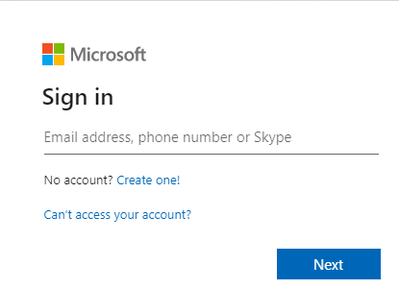
- At the Microsoft password window
Please enter your student password

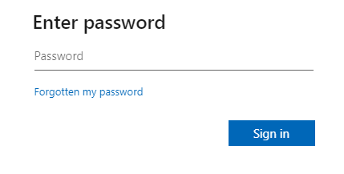
Please follow steps in Moodle Log in video for logging into Moodle
https://itsligo.hosted.panopto.com/Panopto/Pages/Viewer.aspx?id=e6b7174e-32dd-4e8b-ba82-af02008dafaa

