MRes Scholarship Project Information
Flourishing at Atlantic Technological University: Promoting Education for Sustainability

Primary Supervisor: Dr Allison Gillen (allison.gillen@atu.ie), ATU Sligo
Co-Supervisor: Professor Jacqueline McCormack, ATU Sligo
Co-Supervisor: Dr Carina Ginty, ATU Galway-Mayo
Study Level: MRes
Duration: 2 years (24 months) full-time
Location: ATU Sligo, Ash Lane, Sligo, F91 YW50, Ireland
Expected Starting Date: Mid/End of May 2023

Description of the Research Project
An exciting opportunity for an MRes candidate to join a multidisciplinary team led by Atlantic Technological University Sligo and Galway-Mayo, to conduct research as part of the N-TUTORR Project. The National Technological University Transformation for Recovery and Resilience (N-TUTORR) Project which is EU funded and overseen by the HEA, proposes to utilise the national scale and scope of the technological university sector in Ireland to deliver a best-practice suite of initiatives and opportunities for learners, for staff development, and supported by enabling technologies. N-TUTORR is a partnership project between all of the Technological Universities and Institutes of Technology in Ireland (7 Higher Education colleges in total). The N-TUTORR Project is designed to transform learning, teaching, and assessment by focussing on transforming the student experience and developing the capabilities of all staff to address a sustainable pedagogical and learning environment with a critical focus on the Sustainable Development Goals (SDGs); equality, diversity, and inclusion (EDI); and universal design for learning (UDL). The N-TUTORR Project will promote an inclusive and accessible learning experience to enhance student success for all learners.
The national programme of work of the N-TUTORR Project is designed to enable and leverage digital transformations to achieve sustainable and long-lasting change in the higher education student experience. The N-TUTORR Project aims to implement and utilise digital technologies and platforms in a manner which will enable and empower students and staff to enhance and develop their higher education experience.
There are three streams within the project:
- Transforming the student experience through learner empowerment.
- Transforming learning, teaching and assessment by developing staff capabilities.
- Enabling digital ecosystems to transform learning, teaching and assessments.
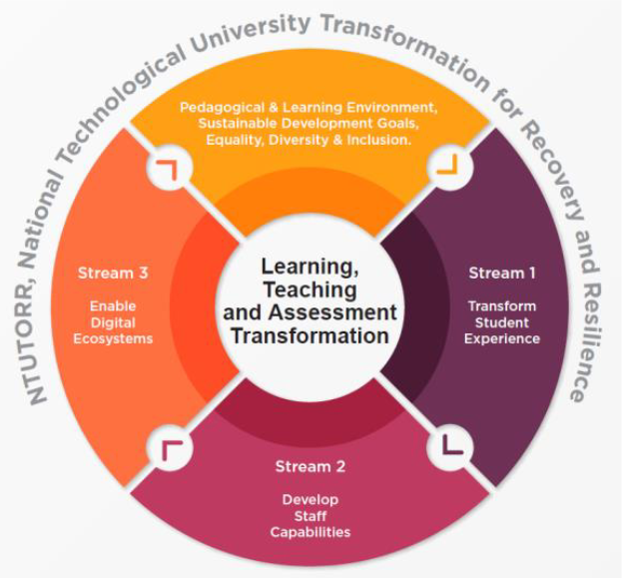

The current MRes research project is focused on Stream 2 (Staff Capabilities). Stream 2 aims to enhance the capabilities of staff in the areas of sustainability, universal design for learning, academic integrity, and digital technology, equipping them to deliver a new sustainable higher education curriculum framework across the university. The current MRes research project aims to gather, analyse, and report on quantitative and qualitative data from Atlantic Technological University at key stages during the implementation of this Stream of the N-TUTORR Project, to explore the barriers and facilitators of engagement and implementation, and to evaluate the effectiveness of the “Academic Champion” approach which is being used within Stream 2. In the current research project, a large focus will be placed on the collection, analyses and reporting of qualitative and quantitative data from interviews, focus groups, surveys, and other sources of data, and subsequently to apply the PERMA+ model for human flourishing (Seligman, 2011) to produce a framework for the subsequent roll out of Stream 2 (Staff Capabilities).

The Applicant
The applicant should be a highly motivated individual who holds a 1st or 2:1 Honours Undergraduate degree in Psychology or a 1st or 2:1 Honours Undergraduate degree in a joint award where Psychology is a major component (i.e., that at least 50% of the modules are Psychology based and the final year Research Project/Dissertation has been completed in Psychology, to include primary data collection and analyses). The applicant must be fluent in English with excellent oral and written communication skills (see conditions below). The applicant will be expected to work on their own initiative, to work with project collaborators, and to be willing to acquire the broader skills necessary for the successful completion of a MRes project.
Previous experience in gathering qualitative research data, analysing this using NVivo or appropriate software, and appropriately reporting is essential. Previous experience in gathering quantitative research data, analysing this using SPSS or appropriate software, and appropriately reporting is essential.

Conditions
- Scholarship €18,500 (per year) and the fees will be paid.
- Postgraduate registration and tuition fees will be covered by the N-TUTORR Project funding as appropriate.
- Material costs and any necessary national and international travel as part of the project will be covered by the N-TUTORR Project funding as appropriate.

Applications
Interested applicants are required to read the terms and conditions, complete an application form (both available on the research page https://www.itsligo.ie/research/) that will include (in a single MS Word or PDF document):
☐ MRes Scholarship Application Form.
☐ A cover letter outlining personal motivation to pursue an MRes and how you meet the requirements of the position.
☐ Transcript(s) substantiating your academic qualifications.
☐ A brief curriculum vitae (CV) that includes contact details for two referees.
☐ Transcripts substantiating your English Language qualifications (if applicable).

Completed applications should be submitted directly to Veronica Cawley at veronica.cawley@atu.ie by 5.00pm on Monday 17th April 2023. All applicants are to provide a breakdown of module names and grades for any degree(s) specified and transcripts as required.

