ATU SLIGO- STUDENT PRINT TOP-UP CREDIT
Log in here with your student credentials: https://ma2942534.ysoft.cloud/end-user/ui/

Click on Payment
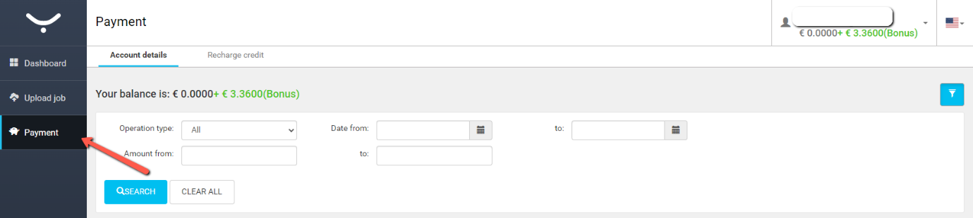
Click Recharge credit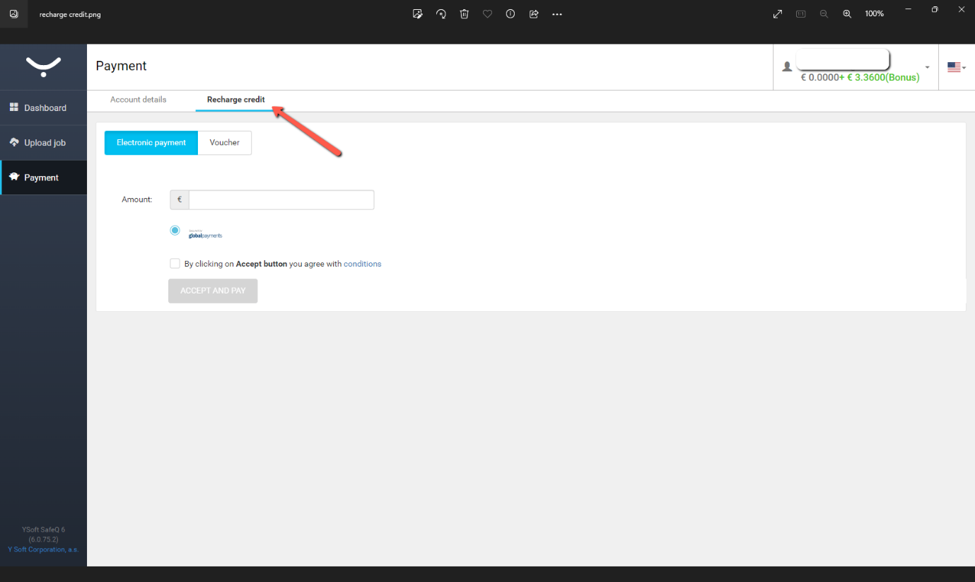
- Enter the top up amount
- Agree to conditions
- Click ACCEPT AND PAY
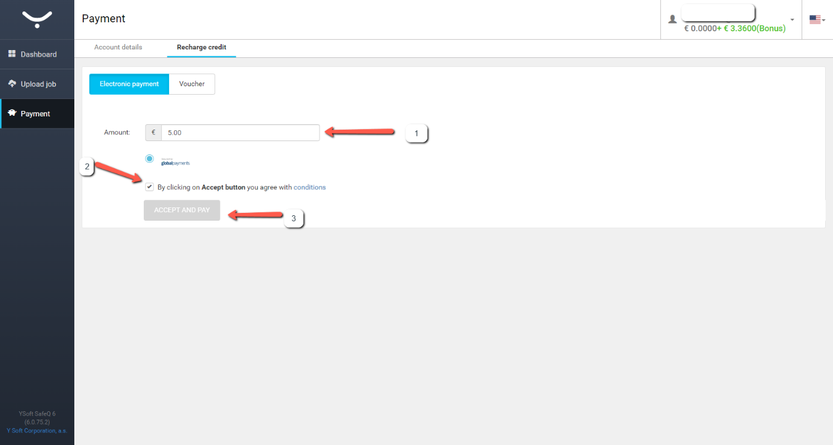

Fill in your information and click continue
Enter your card details and click PAY NOW
