ATU SLIGO - STUDENT PRINTING

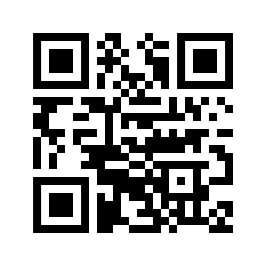
Log in here with your student credentials: https://ma2942534.ysoft.cloud/ - to generate a card activation code or generate pin (you may need to log in twice)

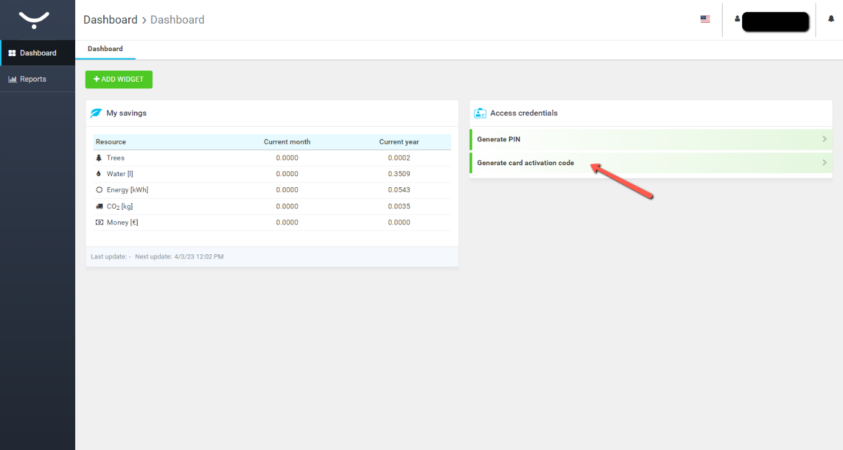

- To activate, go to MFD (multi-function device).
- Scan your card and enter activation code. Alternatively, you can log in with your pin if you do not have your student card

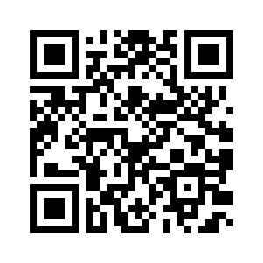
Log in here with your student credentials: https://ma2942534.ysoft.cloud/end-user/ui/ - for uploading a print job and to top-up credit

Select Upload job
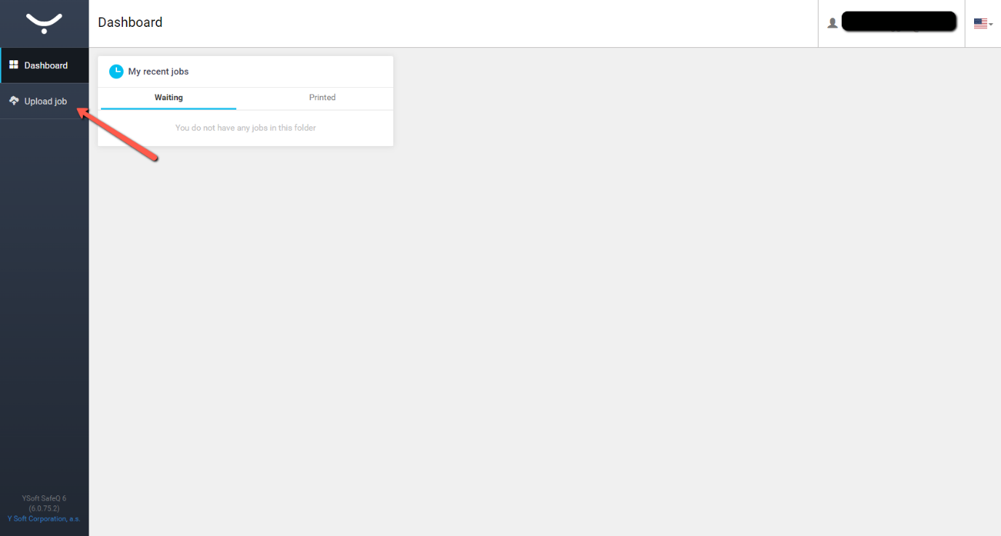
Select the file to print (max upload size 100mb)
NOTE: If you require A3 you must change orientation before uploading the file
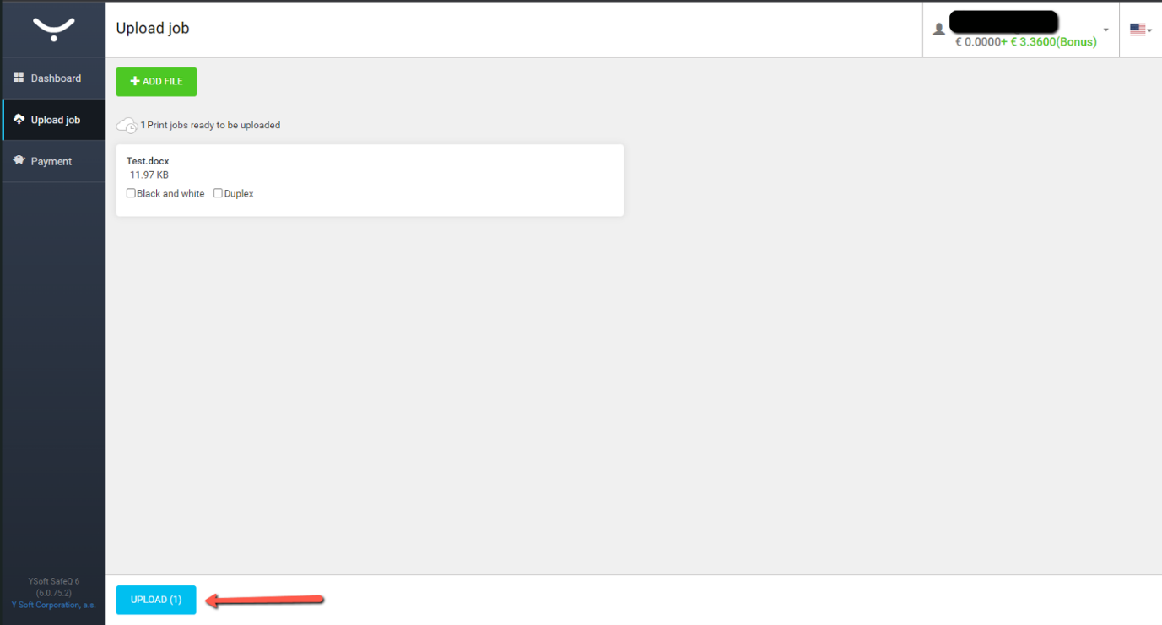Click UPLOAD
Go to the device and hold your student card to the card reader
Activate using code provided (you only need to activate the card once)
Select SafeQ print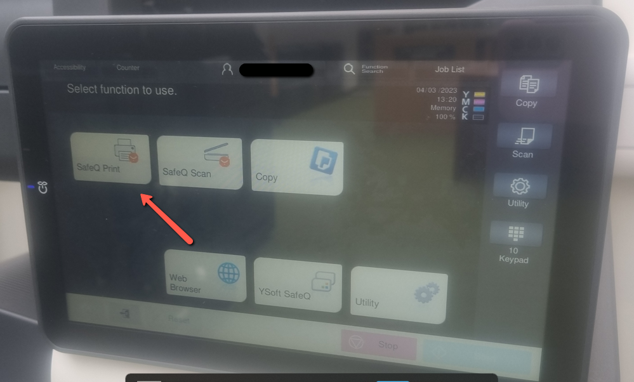

Use the settings to make changes to your print. If you have colour in the file, it will default to print it as colour and you will be charged. You can change it to B&W here

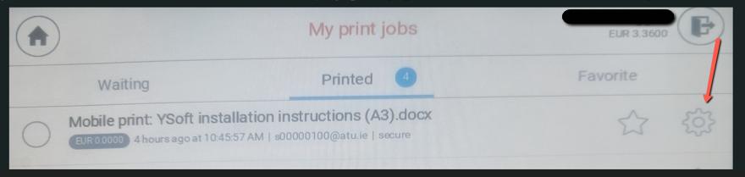
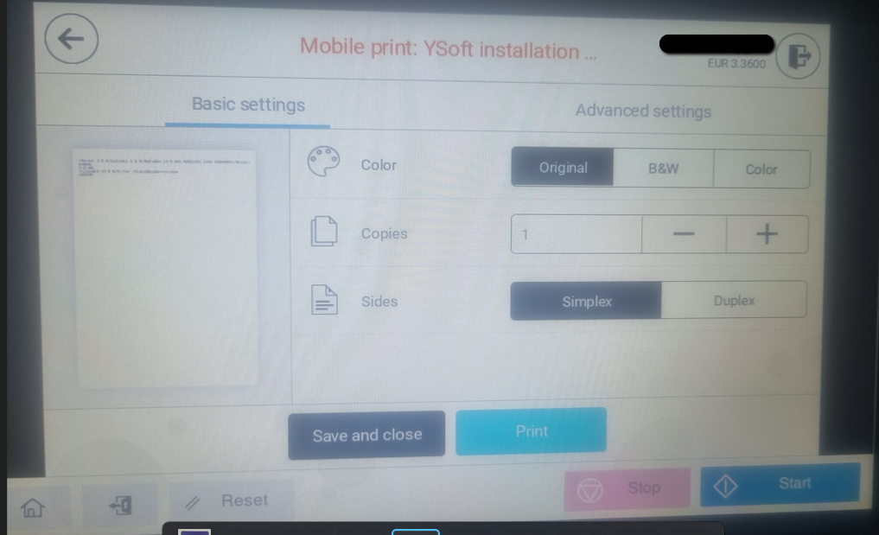
Select Print to start your job

To Scan to email
The MFDs also allow you to scan documents free of charge and have them sent by email to your university account
Select SafeQ Scan from the menu and scan your documents
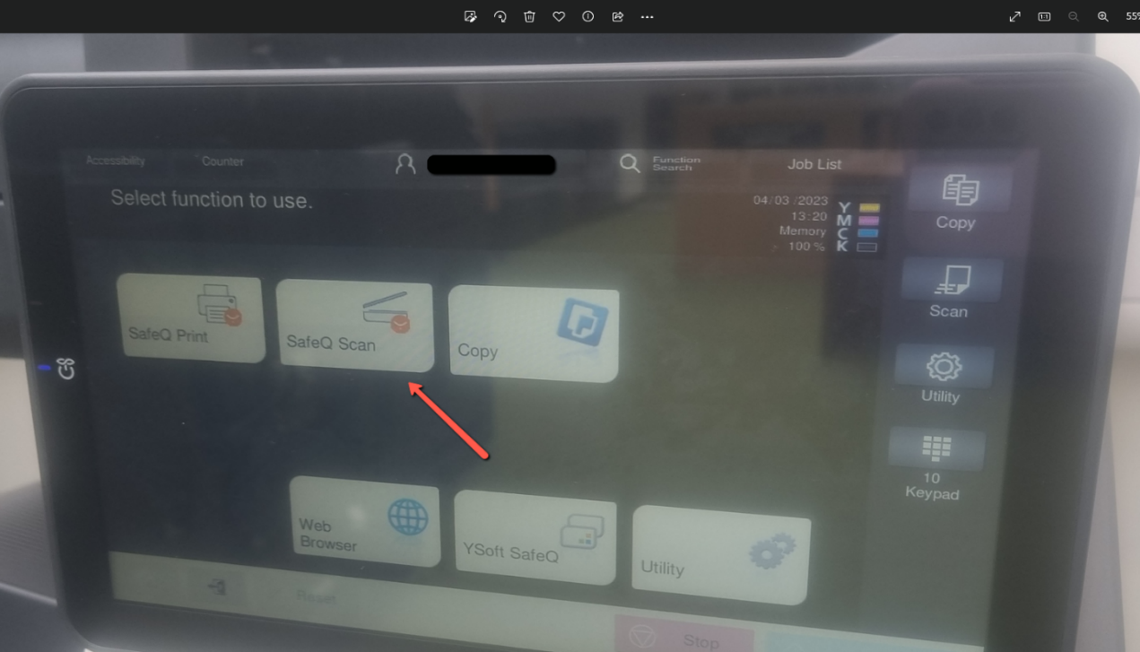
NOTE: Remember to log out of the system by selecting the exit button