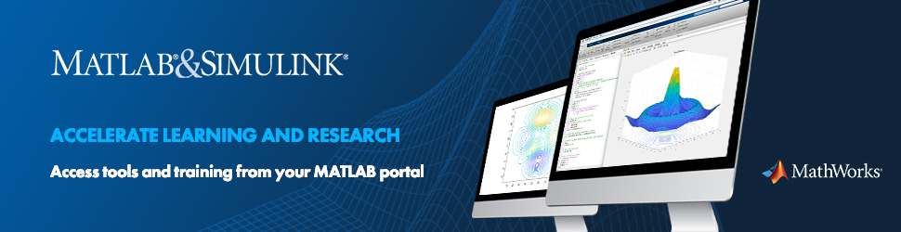

MATLAB Campus-Wide License
Atlantic Technological University (ATU) offers a campus-wide license for MATLAB, Simulink, and add-on products, on and off campus, on any device. These applications are a common set of essential tools for algorithm development, data analysis, modelling, and visualization and readily available for all students, educators, and researchers. The license includes access to MathWorks learning resources and self-paced online trainings to quickly develop your MATLAB and Simulink skills.

MATLAB and Simulink
MATLAB, the language of technical computing, is a programming environment for algorithm development, data analysis, visualization, and numeric computation.

Simulink is a graphical environment for simulation and Model-Based Design of multi-domain dynamic and embedded systems.

MathWorks produces nearly 100 additional products for specialized tasks such as data analysis, image processing, computational finance, AI, and much more.

These applications find use in engineering and science, business and economics, and computational finance, amongst others.

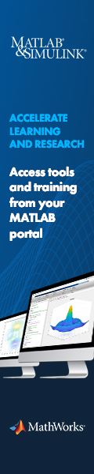
License installation
For instructions on downloading the software and other resources, go to ATU's MATLAB Portal.
To install and activate MATLAB on your device select “Sign in to get started” and proceed with the required steps using your university email address.

For detailed instructions to make use of the license, you can click on the link Contact Support, and
“Need Installation Help?” (PDF) or watch a video to create your account.

Don’t forget, you can also access MATLAB Online: run MATLAB and Simulink on a web browser (ideal back-up solution in in the absence of your laptop which has MATLAB installed on it). Do not use this feature in combination with privacy-sensitive information.

Online training
After activating your account, you’re good to go start using MATLAB. If you are new to the tool, learn the basics at the Getting started with MATLAB page.

Under the section “Learn to Use MATLAB and Simulink”, the portal also provides access to a wide range of interactive online courses and tutorials on MATLAB, Simulink, deep learning, machine learning, computational math, and more. At the end of each course, you can download and print a certificate of completion.

Additional resources
- Quick Start Guide to Teaching with MATLAB: Six steps for bringing resources to your course to catalyse critical thinking and student engagement whether online or in the classroom.
- Resources for Online MATLAB and Simulink: Creating interactive and engaging course materials
- MATLAB Live Editor: Create scripts that combine code, output, and formatted text in an executable notebook
- MATLAB Grader: Automatically grade MATLAB code in any Learning Environment; create an interactive class with MATLAB-based problems. Watch the MATLAB Grader Overview video.
- MATLAB Courseware: Downloadable Course Materials Created by Educators from several universities.
    - MATLAB Parallel Server: Perform MATLAB and Simulink computations on clusters and clouds

